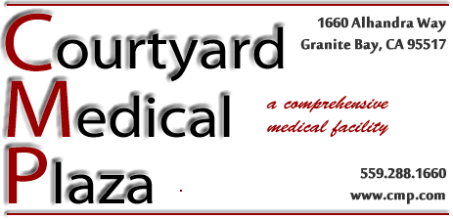Tips for Staying Active

Almost any activity that gets you moving and strengthens your muscles is good for your health and can help you meet your fitness and weight goal. If you haven't been exercising regularly, start out slowly and gradually increase duration, frequency, and intensity. If you have been exercising regularly, keep it up!

# Staying Active

1. Aim for at least 30 to 60 minutes of moderate intensity activity on most days.
   1. You can get your exercise all at once or spread it out during the day.
      1. For example, exercising for three 10-minute periods is just as effective as exercising for 30 minutes at a time.
   2. The more physical activity you do, the more calories you burn and the greater the health benefit.
2. If you don't like counting calories, try counting your steps!
   1. Walking 10,000 steps a day can help you manage your weight.
   2. Use a pedometer (an easy-to-wear device that senses your body's motion) to count your steps and motivate you to increase your activity.
   3. Use a journal to track your walking.
3. Use both aerobic and strengthening activities are important to losing weight and keeping it off.
   1. As you grow older, your body slows down and your metabolism—the rate at which your body burns calories—naturally decreases.
   2. Taking a brisk walk will boost your metabolism and keep you burning calories for hours afterward.
4. Remember that any form of exercise is good for you.
   1. Household chores
      1. Cleaning windows
      2. Vacuuming
      3. Folding clothes
   2. Yard work and gardening
   3. Using stairs rather than an elevator
   4. Getting up and moving regularly at work

# Keep Exercise Fun and Interesting

* Pick one or more activities you enjoy. Regular exercise is more likely to become a healthy habit when it's fun as well as rewarding. Varying your activities can help prevent boredom.
* Exercise with a friend. The support and companionship will help keep you going.
* Think about the payoffs. Exercise not only helps control weight, it is beneficial to the body and mind in several ways. It improves health, boosts your immune system, helps control appetite, helps you feel more energetic and relaxed, and raises your self-confidence!
* Set realistic exercise goals. Reward yourself in healthy ways when you achieve them.